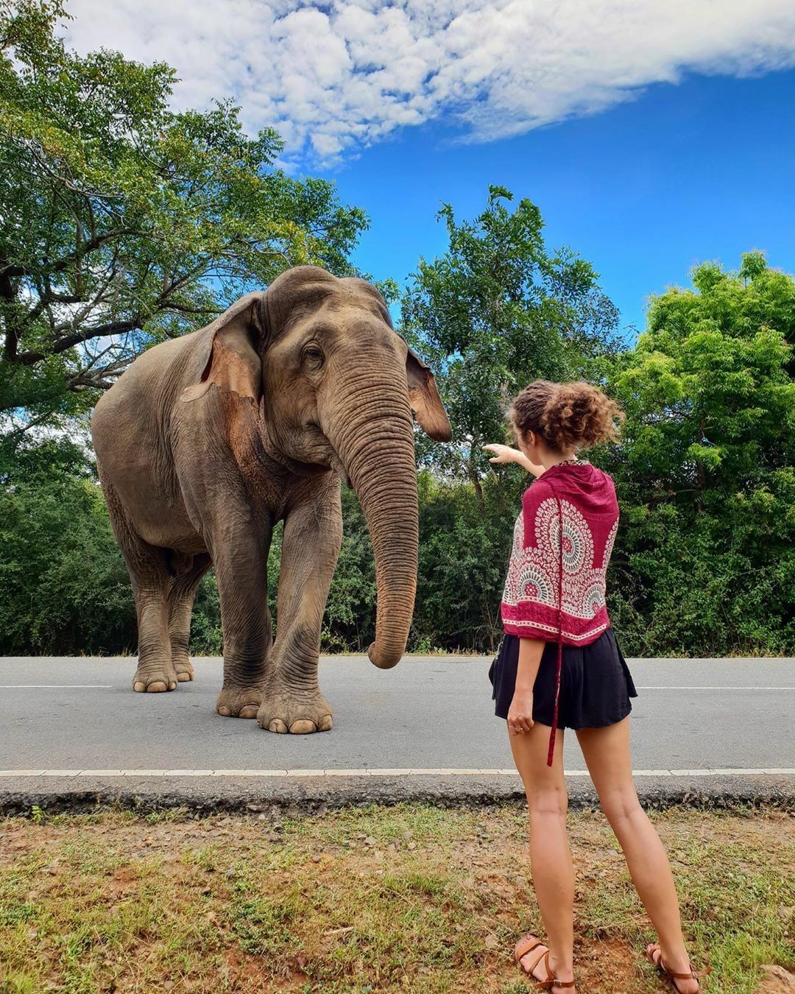

10 Nights & 11 Days
Sri Lanka

Day 01 |  | Airport – Anuradhapura
Arrive at Colombo International Airport. Here, you will be met by an airport representative and designated guide from Esna Holidays. After the formalities at the airport, you will be escorted to your air-conditioned vehicle and then proceed to Anuradhapura.

On completion, check into the hotel and relax

Dinner & Overnight Stay in Anuradhapura

Day 02 |  | Anuradhapura – Habarana
Breakfast at the hotel.

Explore Ancient the city of Anuradhapura

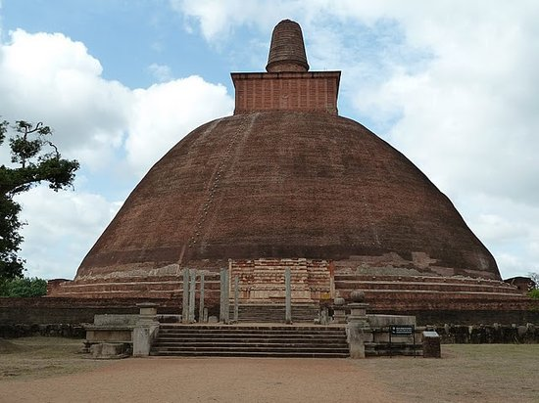
It is the capital city of North Central Province, Sri Lanka and the capital of Anuradhapura District. Anuradhapura is one of the ancient capitals of Sri Lanka, famous for its well-preserved ruins of an ancient Sri Lankan civilization. It was the third capital of the kingdom of Rajarata, following the kingdoms of Tambapanni and Upatissa Nuwara.
The city, now a World Heritage site, was the center of Theravada Buddhism for many centuries. The city lies 205 km (127 mi) north of the current capital of Colombo in the North Central Province, on the banks of the historic Malvathu River. It is one of the oldest continuously inhabited cities in the world and one of the eight World Heritage Sites of Sri Lanka.

After that proceed to Dambulla.

Visit Dambulla Cave Temple.

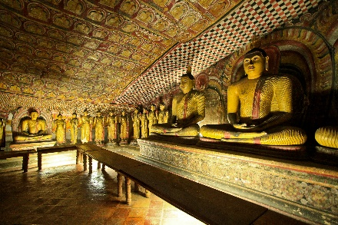
The Dambulla temple has five caves and 157 statues of the Lord Buddha, many paintings on the ceilings and walls that emphasis the artistic talent of ancient days. The history of the caves, rock and temple dates from the 1st century BC. The fascination of these caves is not only the statues but also the many intricate and delicate paintings that cover the ceiling and walls, created with indigenous traditional paints. Because of the history, archaeological and artistic implications, the premises were declared as one of the UNESCO World Heritage sites in 1991. The temple has been in use for over 22 centuries and still holds a sense of benevolence and spirituality.

On completion, check into the hotel and relax

Dinner & Overnight Stay in Habarana.

Day 03 |  | Habarana – Polonnaruwa – Habarana
Breakfast at the hotel.

Visit the Ancient City of Polonnaruwa a World UNESCO Heritage Site.

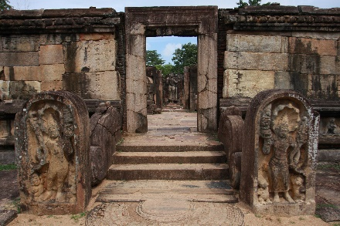
Kings ruled the central plains of Sri Lanka from Polonnaruwa 800 years ago, when it was a thriving commercial and religious center. The glories of that age can be found in the archaeological treasures that still give a pretty good idea of how the city looked in its heyday. You'll find the archaeological park a delight to explore, with hundreds of ancient structurestombs and temples, statues and stupas – in a compact core.

The later evening goes for a Safari Ride in Minneriya.

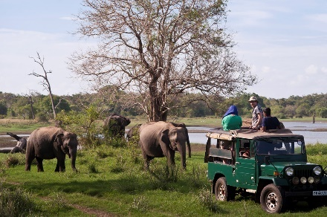
Minneriya National Park: One of the main reasons for visiting the beautiful country of Sri Lanka was to see the Sri Lankan elephant in the wild. Minneriya National Park is one of best national parks to spot Elephants in Sri Lanka. It is home to 200+ elephants, monkeys, crocodiles and even a handful of leopards. The Gathering around the water reservoir takes place in the dry season from July to October. Besides from elephants, there is so much more to see. Peacocks, small black bears, crocodiles, deer, many monkeys and beautifully colored birds.

Check into the hotel and relax

Dinner & Overnight Stay in Habarana.

Day 04 |  | Habarana - Kandy
Breakfast at the hotel.

Visit Sigiriya Rock

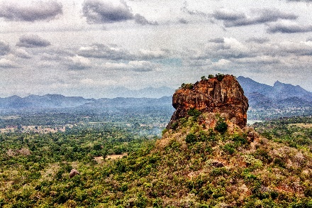
Sigiriya Rock Fortress: Called by many names including “The Lion Rock” for its initial name of “Sinhagiri”, Sigiriya is near the town of Dambulla and is a colossal column of rock nearly 200m high. It was a royal citadel for 18 years (477-495) when it was fortified by King Kasyapa. The architectural and irrigational technologies of Sigiriya, such as the Water Gardens, still baffle engineers. The climb up steep steps of metal with railings passes a wall decorated with frescoes of bare-breasted women. Art experts consider them unique

Visit Nalanda Gedige.
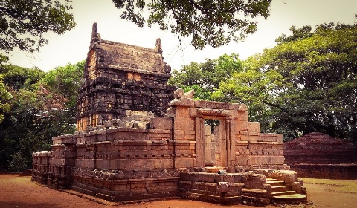
Nalanda Gedige is an ancient complete stone temple near Matale, Sri Lanka and its original site is considered the geographical centre of Sri Lanka. The building was constructed between the 8th and 10th centuries with dravidian architecture in and is believed to have been used by Buddhists. Nalanda Gedige is designed on the lines of a Hindu temple with a mandapa, an entrance hall (originally roofed), a short passage to a bare cello, and an ambulatory round the holy centre. A limited number of the original Hindu deity statuettes exist within the temple, however, a statue of the God Kubera appears on the south side of the tympanum over the sanctuary, a feature that can only be seen in Sri Lanka.

The richly decorated facade sections, laboriously reassembled in 1975, are predominantly in the South Indian style. Although they cannot be precisely dated, they are believed to have originated sometime between the 8 to 11th centuries.

Visit Spice Garden

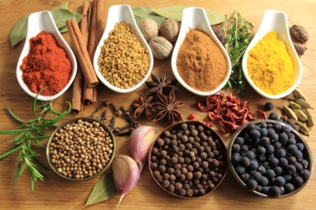
Sri Lanka is world renowned for its valued spices and healing herbs. Our lush spice and herbal gardens feature many important herbs such as Sandalwood, Margosa, Cocoa, Citronella, Almond, Jasmine, and Coconut. When visiting us, make the most of the chance to experience first-hand how cloves, pepper, ginger, nutmeg, cinnamon and saffron are grown in their natural surroundings.
At Regent Spice and Herbal Garden, you can learn of their medicinal healing properties and how to use them in your day-to-day needs. Used worldwide in many medicines, the healing powers of spices have been respected from the time of the Pharaohs and Chinese Dynasties, while our herbs are used in Ayurvedic concoctions.

Experience the Kandy Cultural Show. – Optional – Subject to availability.

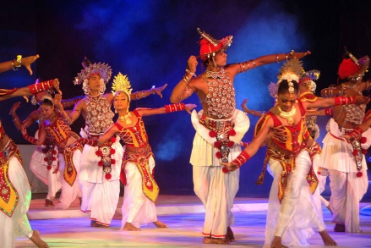
The Kandy Cultural Show gives an opportunity to experience some of the traditions of Sri Lanka. Enjoy this hour-long extravaganza as some of the most popular art forms of the island take to the stage. Be wowed by fire dancers and sword dancers. Watch the colourful Kandyan dancers take to the air to the thrumming primal beat of the drums.

Check into the hotel and relax

Dinner & Overnight Stay at Kandy.

Day 05 |  | Kandy – Nuwara Eliya
Breakfast at the hotel.

Explore the City of Kandy
Sightseeing in *Kandy, including Upper Lake Drive, Market Crafts Centre, and Gem Museum. Kandy the hill capital, venue of the annual Perahera The last stronghold of the Sinhala Kings was finally ceded to the British in 1815.

Visit the Kandy Temple
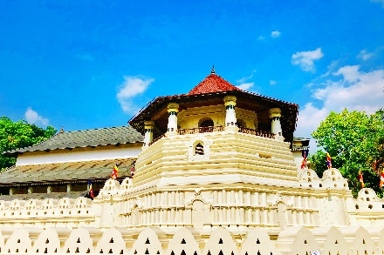
The Temple of the Sacred Tooth (Sri Dalada Maligawa) was originally built by the Kandyan Kings in 1595, to house and honor the sacred tooth relic of the Buddha. Attracting crowds of white-clad pilgrims bearing lotus flowers for means of worship, the Maligawa features a myriad of intricate carvings that speak volumes of the architectural values of Kandy. Today the City of Kandy is a UNESCO World Heritage Site in part because of the Temple of the tooth relic.

Visit Royal Botanical Gardens, Peradeniya

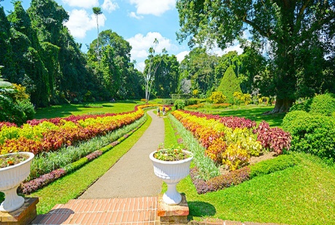
This majestic botanical garden is 147 acres in extent and was started in 1374 as a pleasure garden of the Kings of Gampola and Kandy. There are more than 5,000 species of trees, plants and creepers. Some which are rare and endemic, as well as flora from the tropical world, are found in the gardens. The Spice Garden and Orchid House are popular with tourists. There are 5 Palm Avenues beautifying the gardens, the earliest and tallest, Royal Palm Avenue, was planted in 1905 and the Double Coconuts from the Seashells Island, with the largest seed of all plants in the world, is one such avenue

Learn about Tea Production.

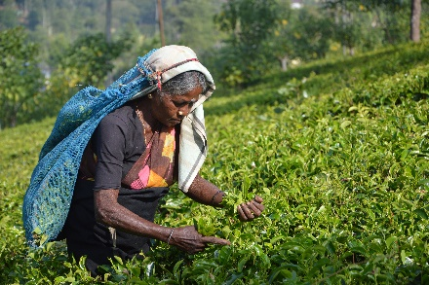
The production of tea involves a tedious procedure of plucking, withering, rolling, oxidizing and drying – a process that requires heavy machines and plenty of manpower. Once in the tea factory, you would generally start out in the plantation itself to learn about how tea is cultivated, then visit the factory where ancient machines pre-dating the industrial revolution wither, roll and dry the tea. There is normally a little time at the end of the tour for a tea tasting, either of one specific type of tea or occasionally of the various specialities of that factory.

Explore the City of Nuwara Eliya.

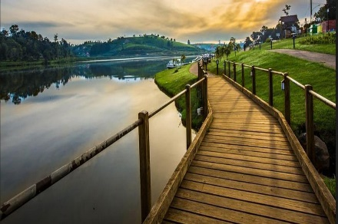
Visit the highland city that was the premium holiday resort town of the British in the 19th and early 20th centuries. Enjoy walking through the streets with their pretty little cottages, quaint villas and beautiful mansions. Make a memory in the old red-bricked post office as you purchase a postcard to take home or send to your friends. Relax at Queen Victoria Park and on the shores of Lake Gregory.

Check into the hotel and relax

Dinner & Overnight Stay at Yala Hotel.

Day 06 |  | Nuwara Eliya – Ella - Galle
Breakfast at the hotel.

(Optional) Train ride from Nuwara Eliya to Ella.
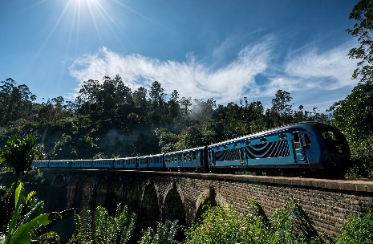
1192Train Ride: The train trip to Ella is not only taken by tourists but by locals themselves. This isn’t just a tourist attraction, it’s life for the people of Sri Lanka. The lush green hills are purely breathtaking. The train takes you high into the mountains, through dense forest & vibrant green tea fields, over bridges, through tunnels, local villages and beside smiling faces. If you look closely every so often, you’ll notice the colorfully dressed ladies pop their heads up amongst the tea fields as they carry on with their work. The stations are old & the trains are even older, but this adds to the journey. It adds so much character! On arrival to Ella, your chauffer will pick you up.

Ella is a small mountain village near Bandarawela and boasts three locations linked to the Ramayana where local legend claims Ravana was hiding Sita. First there is the Ravana Ella Cave, located at the massive Ella Falls; a breathtaking 1080 feet high waterfall that cascades into several falls. The rocky undergoes of the waterfall is Khondalite, a kind of limestone which undergoes faster decay as hard gneiss or granite. This has resulted in many caves being formed near the falls. King Ravana is said to have lived in one of the caves above the waterfall. A nearby pool bored out of the rock by the gushing waters is where Sita is said to have bathed Ravana.

Visit the Ravana Waterfall

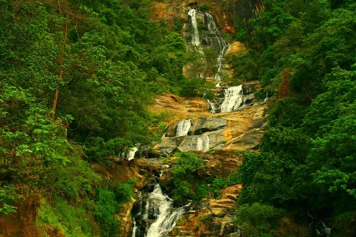
The Ravana waterfall measures approximately 25 m (82 ft) in height and cascades from an oval-shaped concave rock outcrop. During the local wet season, the waterfall turns into what is said to resemble an areca flower with withering petals. But this is not the case in the dry season, where the flow of water reduces dramatically. The falls form part of the Ravana Ella Wildlife Sanctuary, and is located 6 km (3.7 mi) away from the local railway station at Ella.

Visit Nine Arch Bridge, Ella

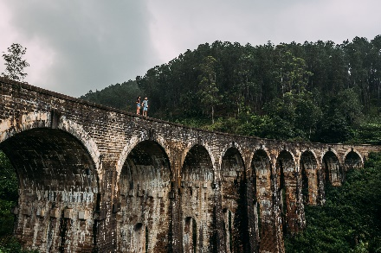
Nine Arch Bridge is one of the best examples of colonial-era railway construction in the country. The construction of the bridge is generally attributed to a local Ceylonese builder, P. K. Appuhami, in consultation with British engineers. The chief designer and project manager of the 'upcountry railway line of Ceylon' project was D. J. Wimalasurendra, a distinguished Ceylonese engineer and inventor. The designer of the viaduct was Harold Cuthbert Marwood of Railway Construction Department of Ceylon Government Railway. The 1923 report titled "Construction of a Concrete Railway Viaduct in Ceylon" published by the Engineering Association of Ceylon has details of all the records including the plans and drawings.

After that proceed to Galle.

On completion, check into the hotel and relax

Dinner & Overnight Stay in Galle.

Day 07 |  | Galle – Bentota - Galle
Breakfast at the hotel.

Proceed to Balapitiya for a Boat Safari at Madhu River.
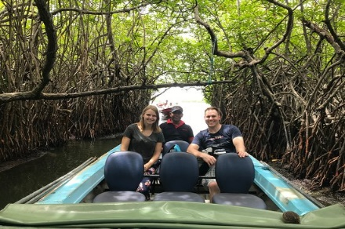
Madu River Ride - Enjoy a scenic cruise along the Madu River, a relaxing trip with plenty of interesting stops. You pass dozens of islets forested with mangroves and can appreciate the timeless natural rhythms of rural life. You cruise in canopies, outboard motors powered boats, en route take in the view of a 200-year-old temple and watch the local’s cultivating cinnamon. You may also see traditional fishing techniques in action and can view demonstrations of coir manufacture and rope making. You can also see 46 species of birds reside in the area including 14 aquatic varieties. You will also spot huge water lilies and colorful butterflies.

Kosgoda Sea Turtle Conservation Project ("KSTCP")

Dudley Perera's project has been underway since 1988. The main aim of the project is to monitor local sea turtle activity and conserve the local nesting sites. We aim to make the public more aware of how endangered these beautiful creatures are and just how important it is to help protect them before it is too late.

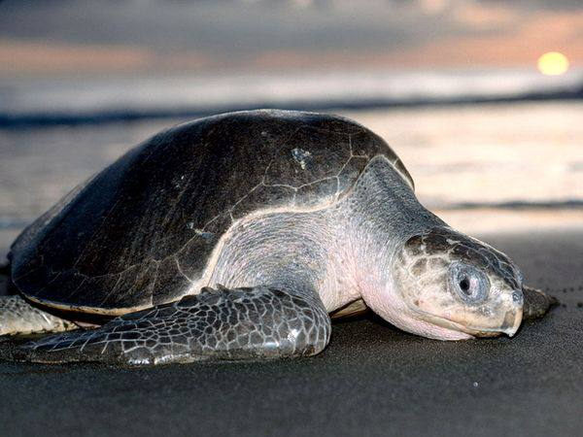
One of the most important activities of the project is its hatchery. Within the sanctuary of the project, collected and rescued eggs can hatch safely away from predators before being released into the sea at night-time. In addition, a certain number from each hatching are kept back for a short period for 'headstarting' before release. The hatchery program is designed to maximize the number of hatchlings reaching the sea and surviving through the critical stages of their early life. Only a few hatchlings from each batch will ever make it to adulthood. Therefore, every nest-ground, every egg, every hatchling, and every turtle is crucial to the survival of the species. Unfortunately, sea turtles face many dangers.

Optional – Water Sports

Bentota is famous for being a top beach in Sri Lanka as well as for its, river cruises and water sports, mainly due to having both river and beach around the location. Here’s our top picks for an unforgettable and adventurous experience in Bentota, Sri Lanka!

Jet Skiing

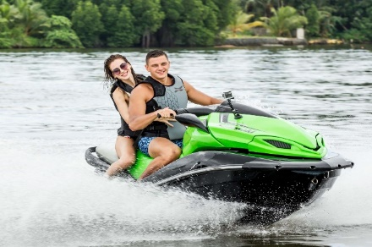
Jet Skiing is one of the most fun and adventurous water sporting activities in Bentota. Though its mostly enjoyed by the trill seeker, beginners can choose to be accompanied by an experienced instructor as well. This is a must do with your friends, family or with your loved ones while in Bentota.

Banana boat & Tube riding

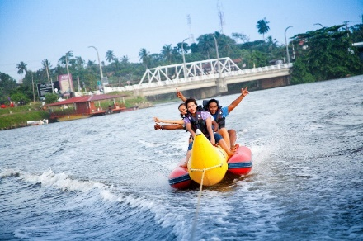
Banana tube is like its name says, shaped like a banana and is attached to a ski boat by roap. The ride will guarantee that huge waves will come thrashing over your heads. While being suitable for any age, you can select from single rings, and sofa rides as well in Bentota.

Return to the hotel and relax

Dinner & Overnight Stay at Galle.

Day 08 |  | Galle – Mirissa - Galle
Pack Breakfast at the hotel.

Early morning proceeds to Mirissa for Whale Watching.
(Whale Watching starts at 06 am)

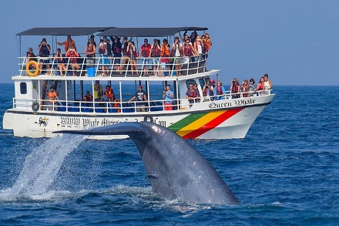
South coast of Sri Lanka, the jewel in the Indian Ocean, swims the majestic blue whale, the largest creature on earth. Nowhere in the world is it possible to see these ocean giants so close to shore. Your whale watching guide will talk to you about the whale experience in Sri Lanka, the marine lifestyle, the conservation of the same and help you see these creatures in the wild as they are meant to be seen. Keep in mind that you are not allowed to snorkel or swim with the whales without prior permission. Such can be obtained only on special requests. We are unable to guarantee the approval for this.

Explore the Galle Fort

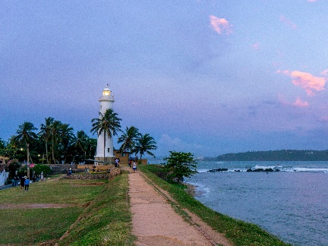
Galle is a historical jewel to Sri Lanka and wonderful to explore on foot. Among the endlessly exotic old trading port blessed with imposing Dutch-colonial buildings, ancient mosques and churches, grand mansions and museums the ancient Dutch fort which is a UNESCO World Heritage Site attracts the hearts of tourists. Stroll around the ancient city where you will find a gourmet of fancy restaurants and coffee shop to chill and relax. The beach side is surely a bliss which will make you want to lock yourself up in this sun-kissed island and indulge in the sea breeze and endless blue waters.

Return to the hotel and relax

Dinner & Overnight Stay at Galle.

Day 09 |  | Galle
Breakfast at the hotel.

Full Day Leisure at the Hotel.

Dinner & Overnight Stay at Galle.

Day 10 |  | Galle - Colombo
Breakfast at the hotel.

Explore the City of Colombo
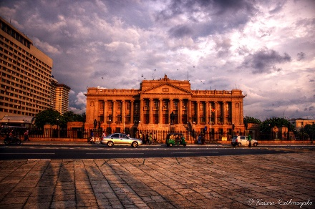
The city tour of Colombo a drive through the city taking you to the busy commercial areas as well as the tree lined residential, Cinnamon Gardens, Visit Fort, the former British administrative centre and military garrison, Sea Street - the Goldsmiths quarters in the heart of Pettah, the Bazaar area, where is also a Hindu Temple with elaborate stone carvings, and the Dutch Church of Wolfendhal dating back to 1749. Also visit the BMICH, see the replica of Avukana Buddha & the Independence Square.

Evening Start Shopping in Colombo

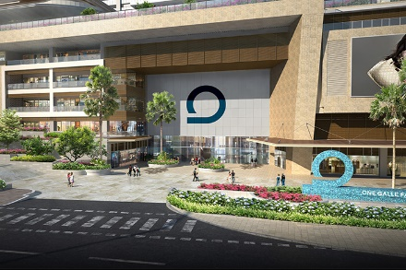
The 5-hectare ribbon of beach stripe, the Galle face green is now the largest open space in Colombo that attracts hundreds of tourists and locals alike. Cotton Collection, House of Fashion and Odel, the largest departmental store in the island offers you stylish clothes to cute souvenirs with elegant Sri Lankan touch, also Beverly Street, visit bargain market in Colombo Pettah, Visit Noritake Showroom, Barefoot, Laksala, One Galle Face & Colombo City Center.

Night Life – Casino drop only will be provided.

A few years ago, Colombo was lacking in a variety of nightlife. Recently, however, a rash of nightspots has popped up in a short space of time giving everyone who likes to indulge in such activities, more options. Although there are several nightclubs and bars catering to young adults, those with live bands (mostly of excellent standard), are very popular with a more mature clientele

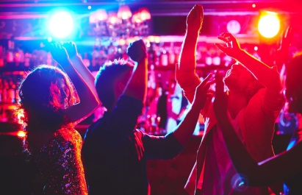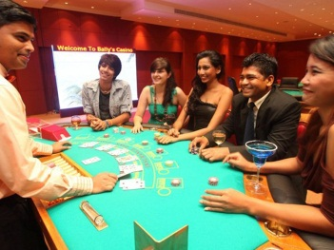

Check into the hotel & relax

Dinner & Overnight Stay at Colombo Hotel.

Day 11 |  | Colombo – Airport
Breakfast at the hotel.

Proceed to the Airport for your departure flight back home with all the memories you had on this beautiful island. [Travelling Time: 1 Hour Approx.]

End of Tour….

Hotels
Location | Hotel – 03 Star | Hotel – 04 Star | Hotel – 05 Star | Nights
Anuradhapura | Miridiya Lake / Similar | Rajarata Hotel / Similar | Rajarata Hotel / Similar | 01 Night
Habarana | Elephas Hotel / Similar | Habarana Village / Similar | Cinnamon Lodge / Similar | 02 Nights
Kandy | Oak Ray Regency / Similar | Cinnamon Citadel / Similar | Golden Crown / Similar | 01 Night
Nuwara Eliya | Ashford Hotel / Similar | Araliya Red / Similar | Araliya Green City / Similar | 01 Night
Galle | Joes Resort Unawatuna / Similar | Hikka Tranz by Cinnamon / Similar | Radisson Blu / Similar | 04 Nights
Colombo | Berjaya Hotel / Similar | Fairway Colombo / Similar | Cinnamon Lake Side/ Similar | 01 Night

Rates are valid from 10 Jan 2023 – 30 Apr 2023
Hotels | 02 Pax | 04 Pax | 06 Pax | 08 Pax | 12 Pax | SGL S | TPL R | C W B | C N B
03 star | 619 | 510 | 470 | 445 | 455 | 262 | 55 | 360 | 250
04 star | 929 | 820 | 780 | 755 | 765 | 553 | 101 | 530 | 346
05 Star | 1095 | 990 | 950 | 920 | 940 | 651 | 148 | 613 | 394

- SGL S – Single Supplement
- TPL R – Triple Reduction
- C W B – Child with Bed
- C N B – Child No Bed
Supplement cost for Entrance Fees (Per person) – (Indian passport holders only)
- US$ 25 Anuradhapura Site
- US$ 25 Polonnaruwa Site
- US$ 48 Minneriya National Park Safari
- US$ 30 Sigiriya Rock
- US$ 12 Dambulla Cave Temple
- US$ 07 Kandy Temple
- US$ 12 Peradeniya Botanical Garden
- US$ 05 Cultural Show
- US$ 03 Gregory Lake
- US$ 12 Hakgala Botanical Garden
- US$ 20 Train Ticket
- US$ 50 Whale Watching
- US$ 05 Galle Mesuem
- US$ 10 Madhu Riverboat Ride
- US$ 05 Turtle Hatchery
- US$ 20 Water Sports at Bentota (Jet Sky + Banana Boat+ Tube Ride) one ride each
- US$ 03 Gangaramaya Temple in Colombo
- US$ 20 Lotus Tower
Value additions
- Complimentary 500ml X 02 Mineral Water Bottle – per person per day throughout the tour.
- Complimentary honeymoon amenities (Bed Decoration, Fruit Platter OR Cake) at any one of the following hotels above.
- Complimentary King Coconut refreshment from Colombo to Kandy.
- Complimentary Sim Card on arrival(T&C) – per room basis.
- Complimentary head & shoulder massage while your stay in Kandy.
- Complementary discount vouchers for shopping in Colombo.
- Airport rep will be available for your assistance 24 hours / 7 days.

Tour Includes
- Meeting and Assistance at the Airport.
- Above-mentioned hotels / similar on HB Basis. (10 Breakfasts + 10 Dinners)
- Transport in an A/C Vehicle with the service of an English-Speaking Chauffeur / National Guide.
- Sightseeing as mentioned above. (Without entrance fees)
- All Taxes.

Tour Excludes

- Visa Charges – USD 22pp (Online)
- Covid Insurance – USD 12pp (Mandatory)
- All Entrance Fees
- Extra PCR Tests as per the airline requirement on departure. (USD 40 per person)
- Early check-in & late checkout.
- Camera & video permits
- Any expenses of a personal nature.
- Any other expenses not mentioned above.
- Tips & Portages.
Important Notes
- Fully vaccinated clients are allowed to enter Sri Lanka. (After 14 Days of completion of the second dose of vaccination)
- Visa must be applied online at www.eta.gov.lk - The Reference number is to be given to the Travel Agent / DMC to approve the Visa for Confirmation.
General Terms & Conditions
www.esnaholidays.com/terms-and-conditions/

