Sri Lanka – Golf Package
07 Nights & 08 Days

Day 01 |  | Airport – Kandy
Arrive at Colombo International Airport. Here, you will be met by an airport representative and a designated guide from Esna Holidays. After the formalities at the airport, you will be escorted to your air-conditioned vehicle and then proceed to Kandy.

Visit Spice Garden

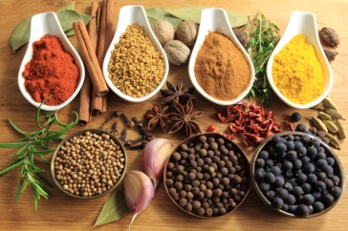
Sri Lanka is world renowned for its valued spices and healing herbs. Our lush spice and herbal gardens feature many important herbs such as Sandalwood, Margosa, Cocoa, Citronella, Almond, Jasmine, and Coconut. When visiting us, make the most of the chance to experience first-hand how cloves, pepper, ginger, nutmeg, cinnamon and saffron are grown in their natural surroundings.
At Regent Spice and Herbal Garden, you can learn of their medicinal healing properties and how to use them in your day-to-day needs. Used worldwide in many medicines, the healing powers of spices have been respected from the time of the Pharaohs and Chinese Dynasties, while our herbs are used in Ayurvedic concoctions.

Check into the hotel & relax

Dinner & Overnight Stay at Kandy Hotel.

Day 02 |  | Kandy
Breakfast at the hotel.

Explore Kandy City

Start Sightseeing in *Kandy, including Upper Lake Drive, Market Crafts Centre, Gem Museum. Kandy the hill capital, venue of the annual Perahera the last stronghold of the Sinhala Kings was finally ceded to the British in 1815.

Royal Botanical Gardens, Peradeniya

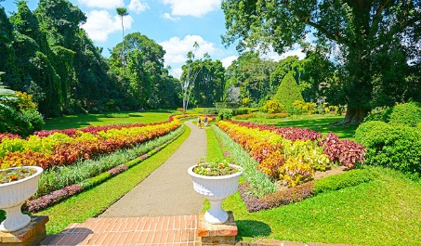
This majestic botanical garden is 147 acres in extent and was started in 1374 as a pleasure garden of the Kings of Gampola and Kandy. There are more than 5,000 species of trees, plants and creepers. Some which are rare and endemic, as well as flora from the tropical world, are found in the gardens. The Spice Garden and Orchid House are popular with tourists. There are 5 Palm Avenues beautifying the gardens, the earliest and tallest, Royal Palm Avenue, was planted in 1905 and the Double Coconuts from the Seashells Island, with the largest seed of all plants in the world, is one such avenue

Optional - Later evening experience at the Kandy Cultural Show.

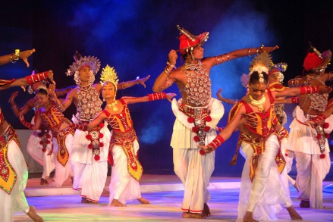
The Kandy Cultural Show gives an opportunity to experience some of the traditions of Sri Lanka. Enjoy this hour-long extravaganza as some of the most popular art forms of the island take to the stage. Be wowed by fire dancers and sword dancers. Watch the colorful Kandyan dancers take to the air to the thrumming primal beat of the drums.

Visit Kandy Temple.

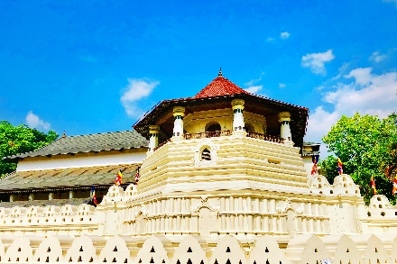
The Temple of the Sacred Tooth (Sri Dalada Maligawa) was originally built by the Kandyan Kings in 1595, to house and honor the sacred tooth relic of the Buddha. Attracting crowds of white-clad pilgrims bearing lotus flowers for means of worship, the Maligawa features a myriad of intricate carvings that speak volumes of the architectural values of Kandy. Today the City of Kandy is a UNESCO World Heritage Site in part because of the Temple of the tooth relic.

Return to the hotel & relax

Dinner & Overnight Stay at Kandy Hotel.

Day 03 |  | Kandy
Breakfast at the hotel.

Full Day play golf at the hotel.

Dinner & Overnight Stay at Kandy Hotel.

Day 04 |  | Kandy - Nuwara Eliya – Ella - Hambantota
Breakfast at the hotel.

Learn about Tea Production.

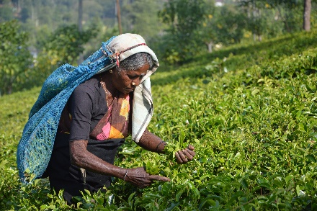
The production of tea involves a tedious procedure of plucking, withering, rolling, oxidizing and drying – a process that requires heavy machines and plenty of manpower. Once in the tea factory, you would generally start out in the plantation itself to learn about how tea is cultivated, then visit the factory where ancient machines pre-dating the industrial revolution wither, roll and dry the tea. There is normally a little time at the end of the tour for a tea tasting, either of one specific type of tea or occasionally of the various specialities of that factory.

Explores the City of Nuwara Eliya.

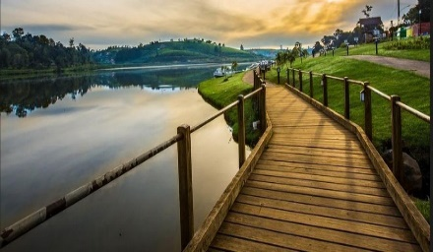
Visit the highland city that was the premium holiday resort town of the British in the 19th and early 20th centuries. Enjoy walking through the streets with their pretty little cottages, quaint villas and beautiful mansions. Make a memory in the old red-bricked post office as you purchase a postcard to take home or send to your friends. Relax at Queen Victoria Park and on the shores of Lake Gregory.

Ella is a small mountain village near Bandarawela and boasts three locations linked to the Ramayana where local legend claims Ravana was hiding Sita. First there is the Ravana Ella Cave, located at the massive Ella Falls; a breathtaking 1080 feet high waterfall that cascades into several falls. The rocky undergoes of the waterfall is Khondalite, a kind of limestone which undergoes faster decay as hard gneiss or granite. This has resulted in many caves being formed near the falls. King Ravana is said to have lived in one of the caves above the waterfall. A nearby pool bored out of the rock by the gushing waters is where Sita is said to have bathed Ravana.

Visit Flying Ravana Zip Line.

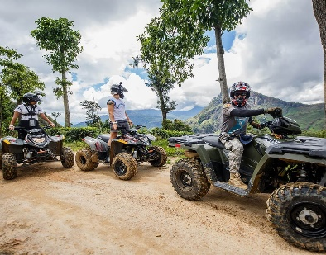
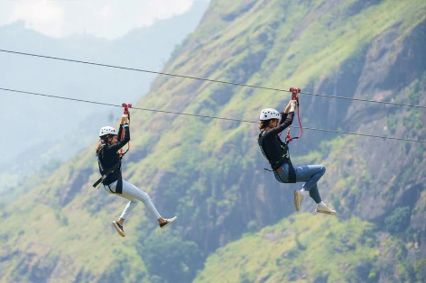

The two-wire zip-line stretches for more than half a kilometer, slides at a maximum speed of 80kmph, and offers a bird’s-eye view of the beautiful hills of the island. Get on board at Mini Adam’s Peak and fly over iconic tea estates and lush greenery overlooking the famous Ella Gap.

Visit Nine Arch Bridge, Ella

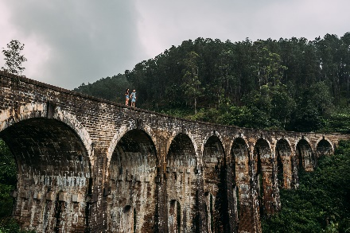
Nine Arch Bridge is one of the best examples of colonial-era railway construction in the country. The construction of the bridge is generally attributed to a local Ceylonese builder, P. K. Appuhami, in consultation with British engineers. The chief designer and project manager of the 'upcountry railway line of Ceylon' project was D. J. Wimalasurendra, a distinguished Ceylonese engineer and inventor. The designer of the viaduct was Harold Cuthbert Marwood of Railway Construction Department of Ceylon Government Railway. The 1923 report titled "Construction of a Concrete Railway Viaduct in Ceylon" published by the Engineering Association of Ceylon has details of all the records including the plans and drawings.

Visit the Ravana Waterfall

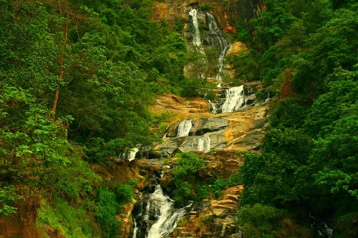
The Ravana waterfall measures approximately 25 m (82 ft) in height and cascades from an oval-shaped concave rock outcrop. During the local wet season, the waterfall turns into what is said to resemble an areca flower with withering petals. But this is not the case in the dry season, where the flow of water reduces dramatically. The falls form part of the Ravana Ella Wildlife Sanctuary and is located 6 km (3.7 mi) away from the local railway station at Ella.

After that proceed to Hambantota.

Check-In & relax at the Hotel.

Dinner & Overnight Stay at Hambantota Hotel.

Day 05 |  | Hambantota
Breakfast at the hotel.

Full Day play golf at the hotel.

Dinner & Overnight Stay at Hambantota Hotel.

Day 06 |  | Hambantota
Breakfast at the hotel.

Full Day play golf at the hotel.

OR

Optional – Yala National Park Safari for half day.

Dinner & Overnight Stay at Hambantota Hotel.

Day 07 |  | Hambantota - Colombo
Breakfast at the hotel.

Proceed to Colombo & Check in to The Hotel.

Afternoon plays golf for half day at Royal Colombo Golf Club.

Optional - Night Life – Casino drop only will be provided.

A few years ago, Colombo was lacking in a variety of nightlife. Recently, however, a rash of nightspots has popped up in a short space of time giving everyone who likes to indulge in such activities, more options. Although there are several nightclubs and bars catering to young adults, those with live bands (mostly of excellent standard), are very popular with a more mature clientele

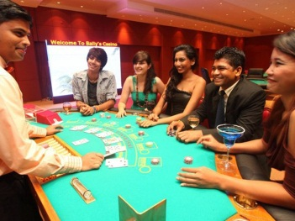

Dinner & Overnight Stay at Colombo Hotel.

Day 08 |  | Colombo - Airport
Breakfast at the hotel.

Explore the City of Colombo

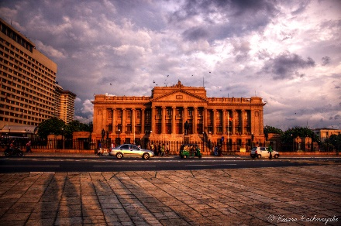
The city tour of Colombo a drive through the city taking you to the busy commercial areas as well as the tree lined residential, Cinnamon Gardens, Visit Fort, the former British administrative centre and military garrison, Sea Street - the Goldsmiths quarters in the heart of Pettah, the Bazaar area, where is also a Hindu Temple with elaborate stone carvings, and the Dutch Church of Wolfendhal dating back to 1749. Also visit the BMICH, see the replica of Avukana Buddha & the Independence Square.

After that proceed to the Airport for your departure flight back home with all the memories you had on this beautiful island. [Travelling Time: 1 Hour Approx.]

End of Tour….

